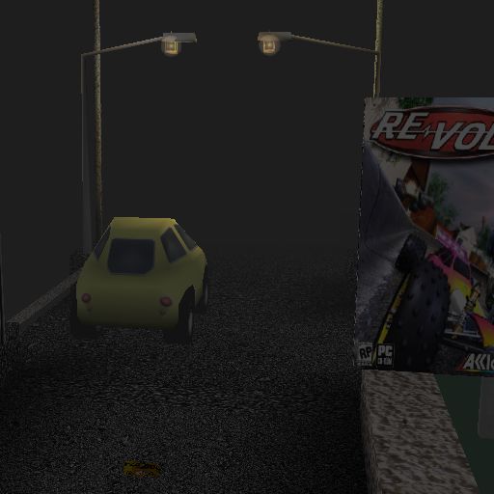
NAME-Night Time Is The Right Time.
AUTHOR- Tarun, taruncreation (on RVL).
TYPE- LEGO-EXTREME.
LENGTH- 1054m.
DIFFICULTY- Medium.
CREATING TIME- 1 Month.

*So here is my fourth lego-extreme track made using track editor. Unlike my previous tracks this one has many new features like triggers etc. In this track you would feature night time with medium fog. Actually there was extreme work more than the lego works.I reworked on AI Nodes, Instances, and Objects. Many features are added like custom music, wavs, load screens, high resolution textures, custom models etc. Hope you all like it. If you find any bug please report it at RVZ and also don’t forget to give feedback.

*Track Editor.
*Makeitgood features.
*MS-PAINT.
*Adobe Photoshop 7.
*Prm-Ncp.
*RV Texture-Resizer.
*Microsoft Office Picture Manager.
*Microsoft Office Word.
*WinZip.
*Format Factory.

*Google for few textures.
*Dyspro50 for his great tutorial on triggers.
*Vaid for telling me about Prm to Ncp.
*Gel38 for giving me Prm to Ncp.
*Creator of Photoshop7, MS-PAINT, Winzip, RV TextureResizer, Prm to Ncp and RE-VOLT.
*EBEE for his varieties of metals.
*You for downloading my track.
*I had used many textures and prm from here and there. Thanks to their creators.

*Many things are taken from another game so I wanted to thank them.
*Many wavs are taken from games like MM2 (Midtown Madness 2), Hot wheels Micro Racers.
*The music is taken from an Android racing game whose name I don’t remember.
*Thanks to Dyspro50 for his great track ‘Dyspropolis’ from where I took the wincar.
*Many instances are taken from Petrovolt Prm Set.

